Contact
Skyla Wayrynen
media@artvancouver.net
Office: 604.682.3701
Cell: 778.858.4450

FOR IMMEDIATE RELEASE

WESTERN CANADA’S LARGEST ART SHOW SETS STAGE FOR BC ARTISTS

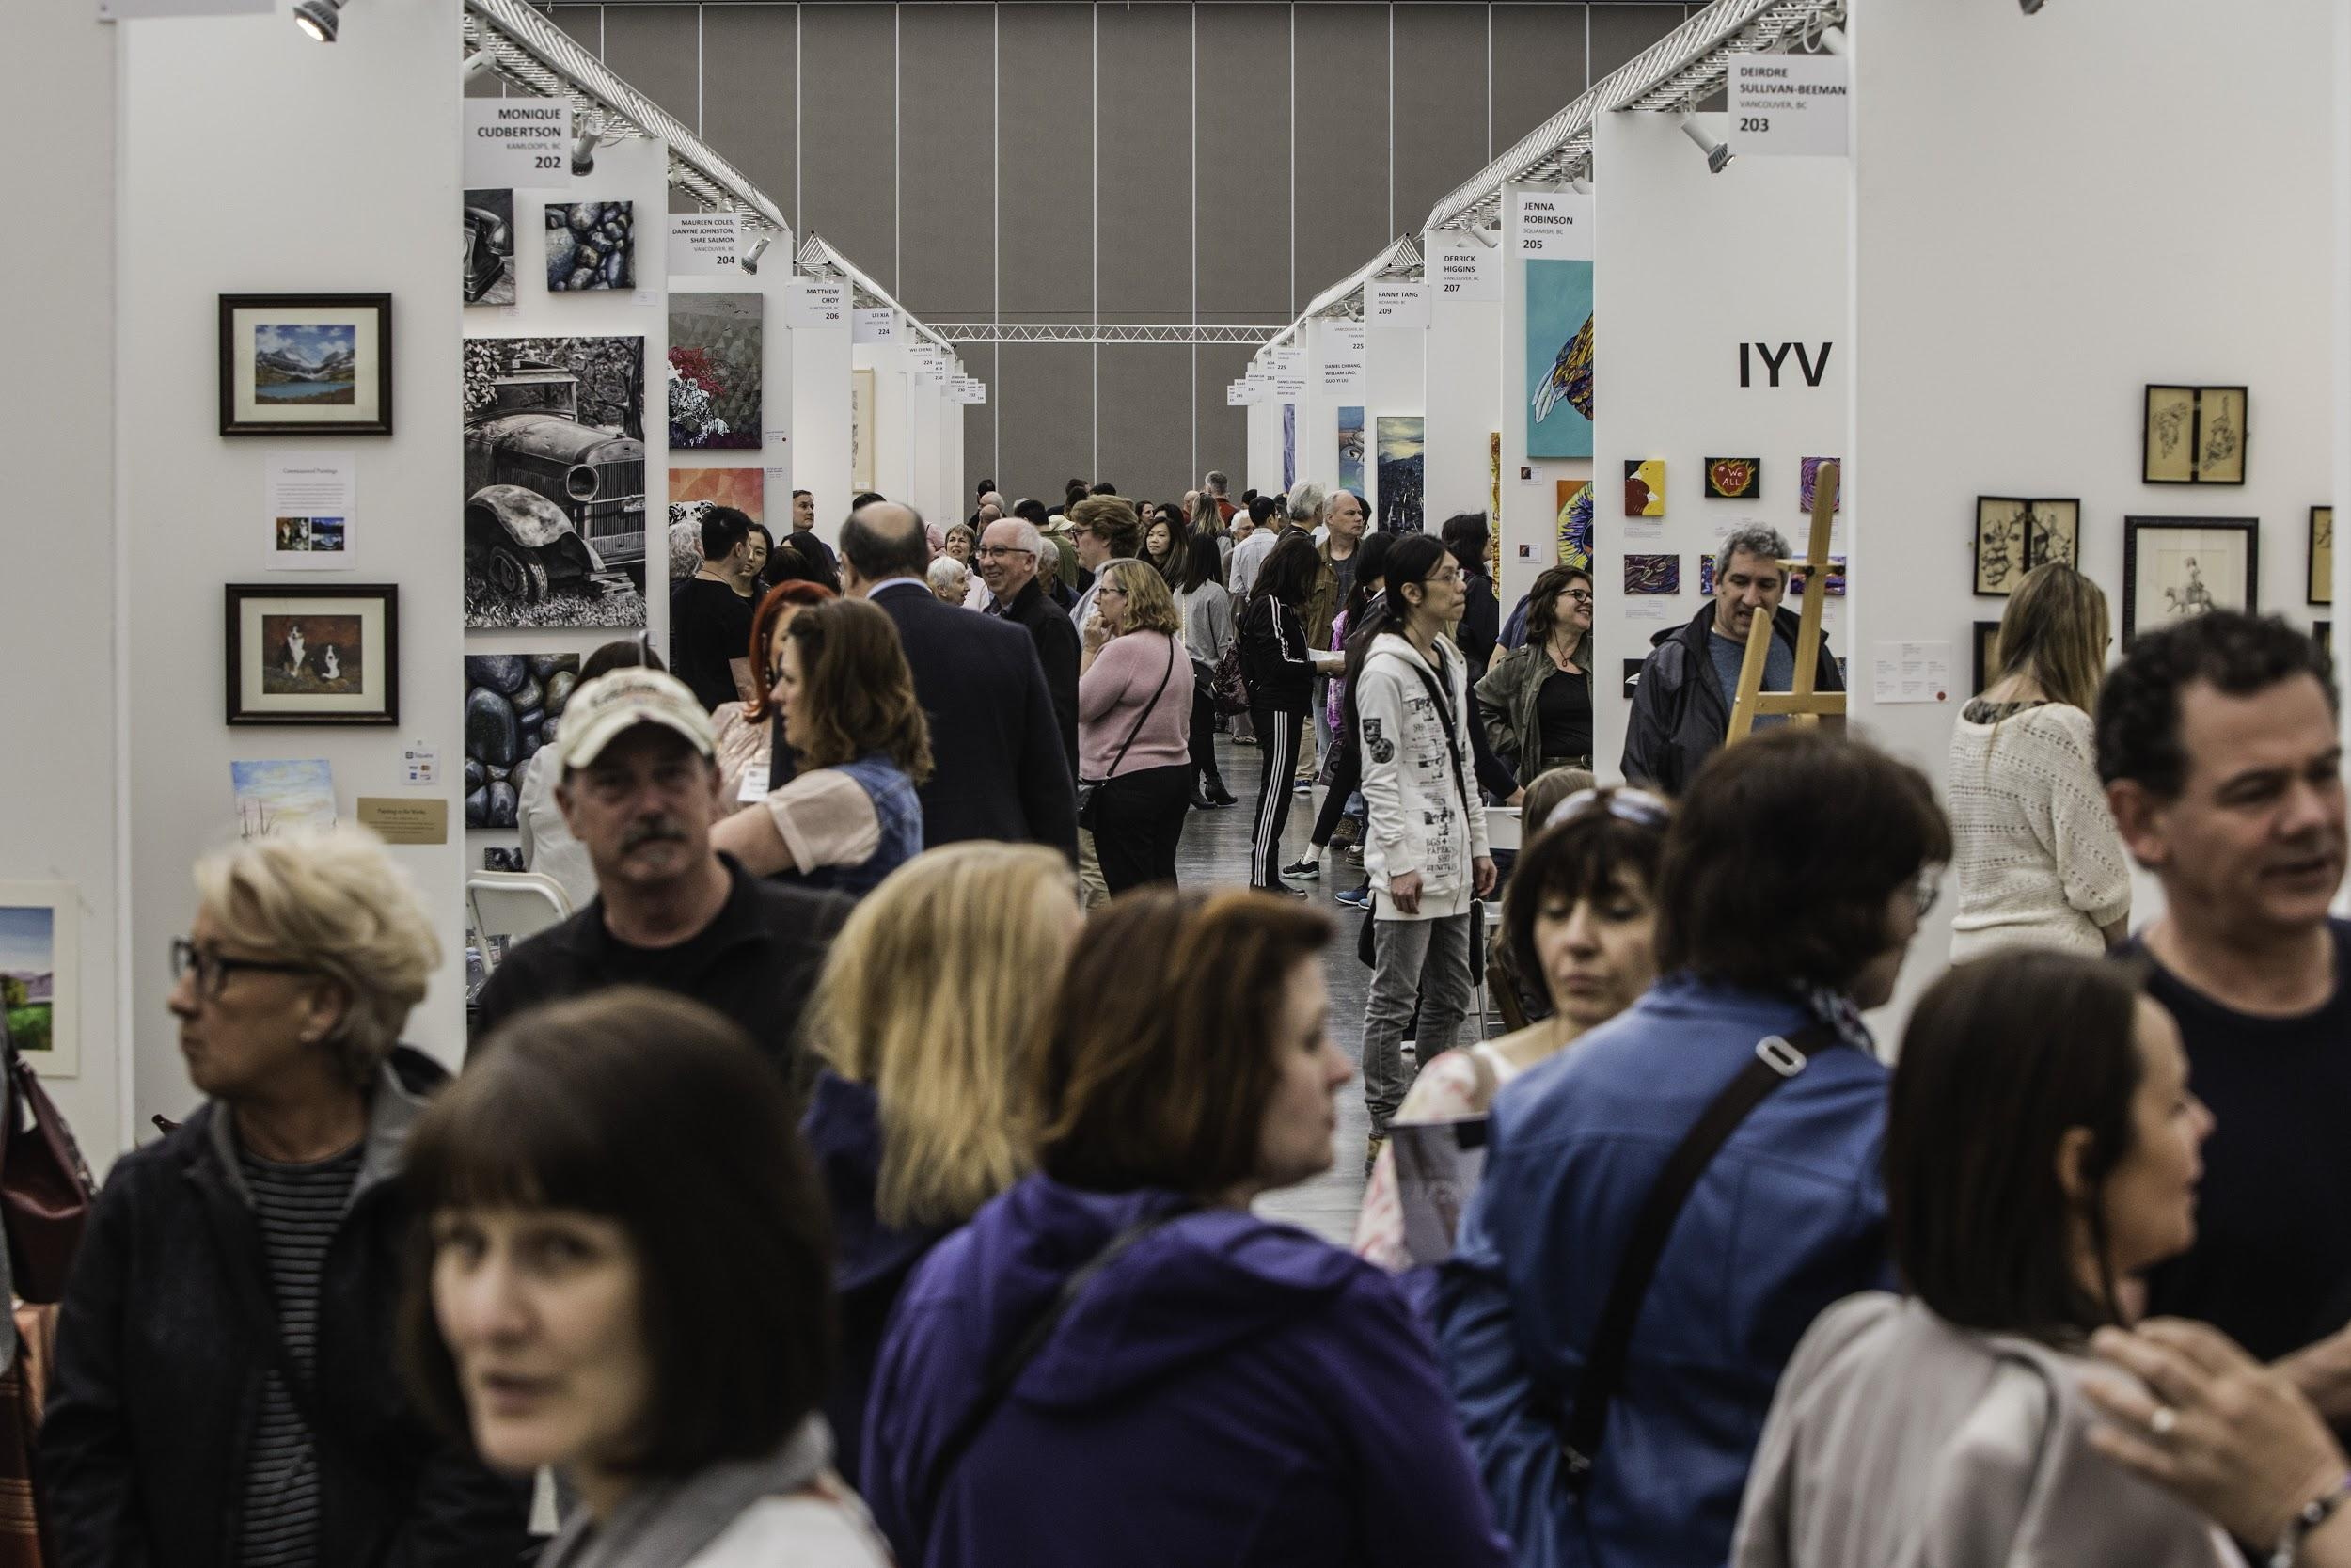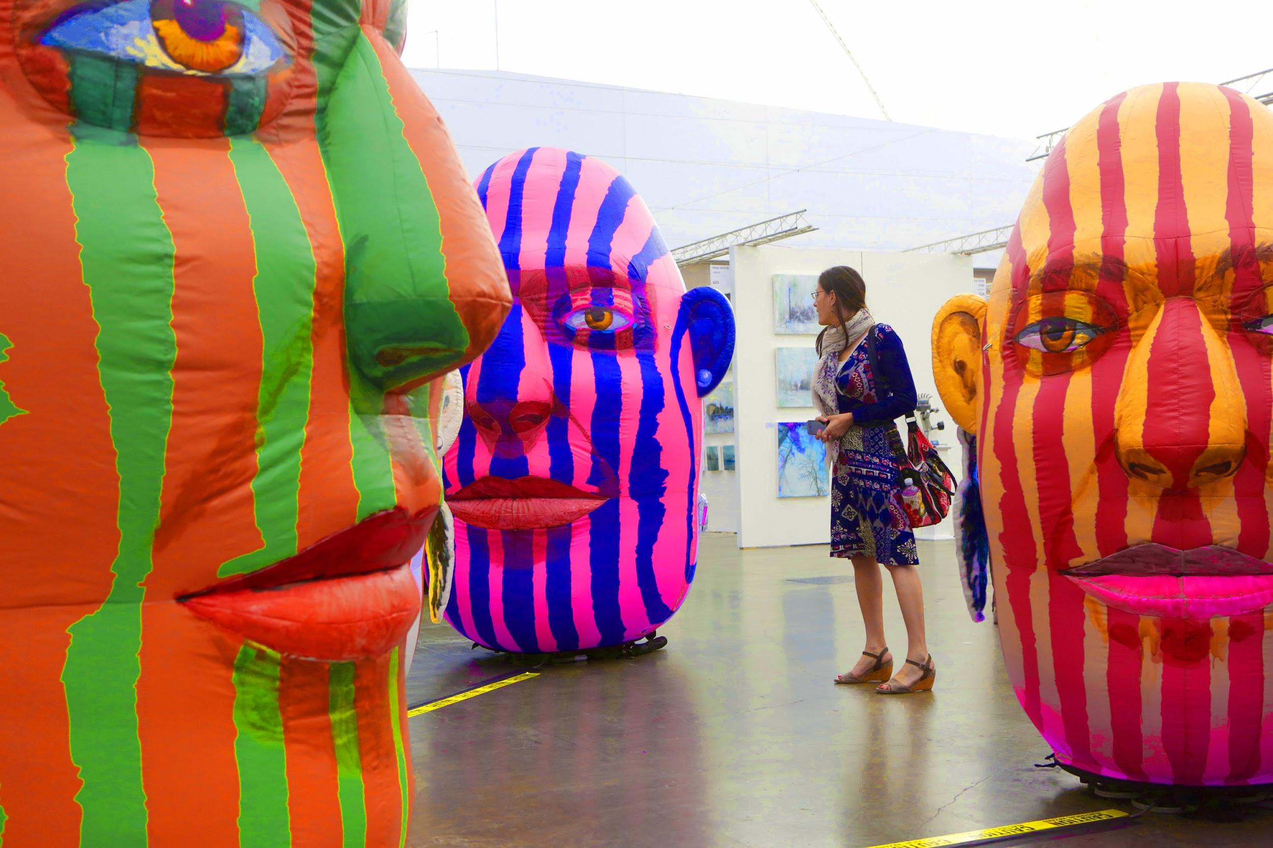

Vancouver, April 3, 2019 - Art Vancouver returns to the Vancouver Convention Centre this year for the fifth time, April 25-28, 2019. As an international, contemporary art fair, artists and galleries come from across Canada and around the world to exhibit their work.
Last year, the event brought in over 90 exhibitors and more than 8,000 attendees. The show also features live artist demonstrations and workshops, keynote speakers, panel discussions and the anticipated Art Masters painting competition. This year it also debuts its new Art Ignites program, which is directed towards educating youth.
Art Vancouver presents a great opportunity for artists of the Pacific Northwest to display their work and connect with collectors and other creative professionals.
With organizational values of promoting inclusivity within the arts community, the show’s roster of international artists has also grown rapidly. Inspired by a range of exhibitors that now represent over 20 different countries, the show’s theme this year is Uniting Nations through Art.
For tickets and more information, please visit https://www.artvancouver.net/.
###
About Art Vancouver
Founded in 2015 by director Lisa Wolfin, Art Vancouver is Western Canada’s largest international fine arts fair and features local and international artists and galleries. The fair includes a diverse collection of exhibitors, along with an Opening Night runway show and an extensive speaker series. The event attracts international visitors with a genuine passion for art, including a range of influential and creative professionals.

